ДЕПАРТАМЕНТ ОСВІТИ
ВІННИЦЬКОЇ МІСЬКОЇ РАДИ
КУ«МІСЬКИЙ МЕТОДИЧНИЙ КАБІНЕТ»
КЗ«ЗАГАЛЬНООСВІТНЯ ШКОЛА І-ІІІ СТУПЕНІВ №10
ВІННИЦЬКОЇ МІСЬКОЇ РАДИ»

ДІЄВІ СПОСОБИ РОЗВИТКУ НАВИЧОК ПИСЬМА УЧНІВ
EFFECTIVE METHODS FOR DEVELOPING STUDENTS’ WRITING SKILLS

номінація «Навчально-методичний посібник»

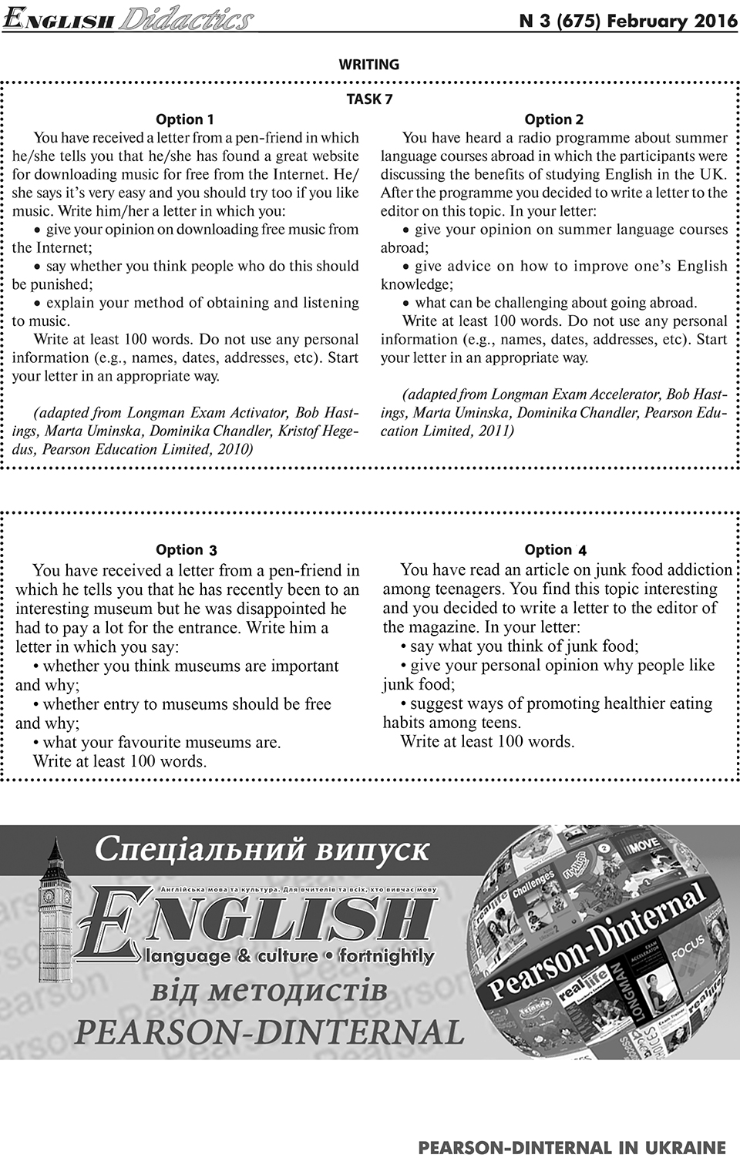
Очеретна Людмила Володимирівна
учитель англійської мови
«спеціаліст першої категорії»
тел. (096) 563-82-39

м.Вінниця
2020
Автор Очеретна Людмила Володимирівна, вчитель англійської мови комунального закладу «Загальноосвітня школа І-ІІІ ступенів №10 Вінницької міської ради»
Очеретна Л. В. Дієві способи розвитку навичок письма учнів/ Effective methods for developing students’ writing skills. Навчально-методичний посібник / Л. В. Очеретна. – Вінниця: ММК, 2020, 42с.
Рецензенти:
Бондар Г. А., вчитель англійської мови вищої кваліфікаційної категорії, «вчитель-методист» закладу «Загальноосвітня школа І-ІІІ ступенів №10 Вінницької міської ради».
Лисенко Г. М., вчитель англійської мови вищої кваліфікаційної категорії, «вчитель-методист» закладу «Загальноосвітня школа І-ІІІ ступенів №26 Вінницької міської ради».
Рекомендовано методичною радою
комунального закладу «Загальноосвітня школа І-ІІІ ступенів №10
Вінницької міської ради»
(Протокол №5 від 28.01.20 р.)
У даному посібнику підібрано та розроблено інтерактивні вправи відповідно до концепції Нової української школи, які спрямовані на розвиток писемної взаємодії та писемного продукування. Матеріали розміщено у порядку ускладнення - від простого до складного через призму сприйняття дитини.
Посібник містить власну розробку уроку, яка ілюструє використання описаних методів.
Навчально-методичний посібник буде у нагоді молодим учителям англійської мови, які прагнуть оптимізувати та урізноманітнити процес формування навичок писемної взаємодії та писемного продукування, вибравши найефективніші методи роботи зі своїми учнями на основі їх пізнавальних здібностей.

Content
s
Introduction 4
WRITING TOOLS 5
Spelling and Handwriting. Visual elements 5
Auditory Elements 11
Kinesthetic elements 13
Digital intelligence. The role of gadgets for developing writing 16
WRITING PROCESS 17
Instruction . Shared Writing 18
Planning and Organizing Ideas 20
How to generate ideas and organize them? 22
WRITING A LETTER 24
Helpful hints 25
Writing in groups based on outline 28
Lesson planning. The example of the lesson 30
APPENDIX 35
SOURSES 42

Introduction
Students should be taught how to be successful writers. Writing is not an easy activity for a teacher and for students either. Taking into consideration the fact that primary school graduates have low-level writing skills (according to the National Curriculum 3rd -4th learners complete sentences giving information about themselves: interests, families, pets using phrases and short sentences), it is a rather complicated accomplishments for secondary school. It is difficult but rewarding.
Writing is a complex skill to develop and master. Writing comprehension only develop when students are taught how to write and are given opportunities to practice these skills.
We need to develop writing skills with students because it is an essential part of language development. Communication in foreign languages is one of 10 KEY COMPETENCIES OF THE NEW UKRAINIAN SCHOOL (the ability to understand adequately concepts expressed in a foreign language, to express both in speech and in writing the ideas, thoughts, feelings, facts and views. By listening, speaking, reading and writing in a broad range of societal and cultural contexts. The skills of direct activity and intercultural communication). Writing is included into external independent assessment.
Pupils should develop competency in two areas: writing tools (spelling, vocabulary, grammar) and writing process (generating and organizing information).Students must require skills to write at length, with accurate spelling and punctuation. They should be taught the correct use of grammar. The writing they do should include narratives, explanations, descriptions, comparisons, summaries and evaluations.
This textbook contains information and handouts that can be used for teaching writing tools and writing process on different stages of learning. The main aim is to help teachers to organize writing activities based on visual, auditory and kinesthetic elements that give students possibility to acquire necessary spelling, grammar, punctuation , vocabulary skills they need to fulfill their writing process . The process that is based on interaction, mutual respect and individual abilities .The writing process that motivates to develop.

WRITING TOOLS

Spelling and Handwriting. Visual elements
It is essential to develop pupils’ competence in spelling and handwriting. Writing down ideas fluently depends on effective transcription: that is, on spelling quickly and accurately through knowing the relationship between sounds and letters (phonics) and understanding the morphology (word structure), grammar, punctuation and writing process as well. The process of teaching writing should include close association of visual, auditory and kinesthetic elements.
For developing visual memory we can use visual cues or images, mnemonic devices, written on our school board, typed on a paper or displayed on the screen. They can be an image, a letter, letter clusters, words, phrases or collocations, phrasal verbs, word patterns, tables illustrating word formation (Appendix 1), articles or letters, texts or stories, “keys” (mnemonics) to remember some pronunciation, vocabulary or grammar.
We can organize different forms of training writing based on visual cues.

“Picture dictation”: teacher shows a picture (an image), students write down the name of it competing in two groups.
“Name the picture”: students label the given pictures in small groups, and then read the words.
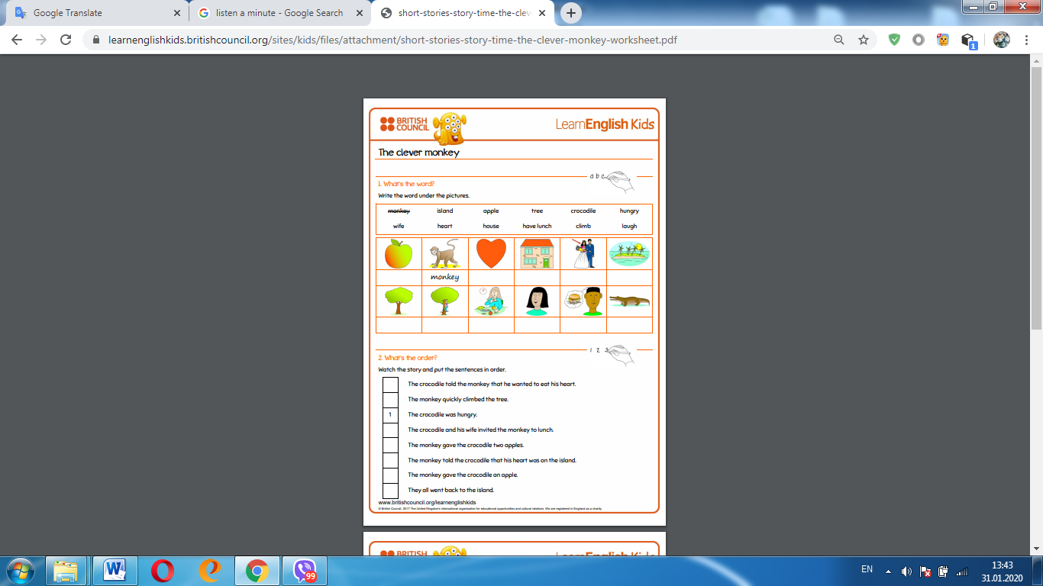

“Unscramble the words”: STs unscramble the given words and write them down (can be done in pairs or small groups). The words should relate to the topic being learned so that the students could use them as a phrase, to write their sentences. For example, the topic is “My friend”, the words are:
avtice, funyn, hys, zlay, nougotig, plotie, siesrou, ured, presolnsibe, ehonst, plouarp.
For correct answers see (Appendix2)
Ough
“Fill in the gaps” with the letters or using the letter clusters (Appendix 3) in pairs, write them down and read. For example,

B____ t, th____ t, b____rt, f_____t.
“Replace the words” in bold with given synonyms or antonyms (opposites) in small groups.
For example, use these verbs in their correct form to replace the words in bold
arrive ●become● buy ●find ●receive ●take
- I think we should get a satellite dish so that we can get more channels.
- I’d like to get a job in the media and learn more about current affairs.
- When the journalist got home, she turned on the TV to watch the news.
- Georgia didn’t want to be late for the interview so she got a taxi.
- Mike got annoyed when he was given a low mark for his essay on the media
For correct answer see (Appendix 4)
“Match word patterns” according to the rule (Appendix 5) and fill in the gaps with them (in the written dialogue) in pairs. For example,
bored  crazy  good  interested  keen  popular  listen | at  on  with  about  with  to  in
Dialogue
- Do you listen… pop music?
- Yes, I do, but I’m not very keen …it. I’m crazy … about rap. Are you interested … rap?
- Yes, but I am not good … reading it. Rap is not popular … my classmates. That’s why I’m bored… with them.
Students may finish writing dialogue on their own.
Replacement exercises: students rewrite and use information that is given (about a person/two people instead of one/, event, country) in small groups.
For example,
Read the model paragraph below and then look at the information about Alfredo and Teresa. Rewrite the model paragraph and use the information about Alfredo to write a description of him. Write another paragraph and use the information about Teresa to describe her.
Roberto is a boy from Venezuela. He lives in Caracas. He is fourteen years old. He studies English in school. His hair is black. His eyes are brown. His favourite sport is soccer. His hobbies are swimming and soccer. Roberto has one brother. His name is Alfredo. Roberto has one sister, too. Her name is Teresa. Roberto has a pet parakeet. Its name is Pele.
Alfredo | Teresa
13 years old  Hobbies: riding a bicycle, watching TV  Hair colour: brown  Eyes: brown  Favourite sport: running  Foreign language:English  Pet: one dog named Charlie | 16 years old  Hobbies: dancing, playing the piano, singing  Hair colour: brown  Eyes: blue  Favourite singer: Jose Luise Rodriguez  Favourite dance: the Hustle  Foreign languages: English and French  Pets: two cats named Tilin and Nieve
See (Appendix 6)
Gapped text : complete the text with the words (it can be even a letter without opening and closing remarks, expressing opinion and linking words that are suggested in word bank for groups of 4-5 students.

For example,

Complete the gaps with the words: I am happy ,Sorry(2 times), Anyway, Thank you, I think, Moreover ,Therefore, I’m convinced ,Besides ,I am good , Hope to hear, Best wishes

Dear Susan,

1)………….for your letter. 2)…….., I have taken so long to put pen to paper.3)…….., I thought I’d drop you a line to let you know how I’m getting on.

4)………….to hear that you are preparing to take part in the School Talent Competition.5)………. you’ve made the right decision! 6)……., I’m sure that you shouldn’t be shy since your special talent is great!

7)…………..that sharing you talent with others is very important as it makes other people happy and boosts your confidence.8)………, the more you practice, the more brilliant your talent becomes, which, in its turn, makes you a more interesting personality.

9)………….at Oriental dancing. I go to dance class three times a week and I take every opportunity to practice it outside the class.10)………., I regularly take part in various competitions and shows.

11)…………, my mum is calling me, so I must finish now.12)……. from you soon.

… …,

Kate

For correct answer see (Appendix 7)

Reorder text ( after reading a letter or getting acquainted with the structure of the letter students write mixed sentences of the given paragraphs of the text in order ) in small groups (Appendix 8).
Controlled composition – students are given a form, using it they must complete a piece of writing (for example, a letter or a dialogue). They may add more sentences if they want to get higher results. Students work individually.
For example, an incomplete letter for the 5th formers .
Task: use the form below. You may add more sentences if you wish. Be sure to give your correct address at the top. Use correct punctuation and capital letters.
Number and Street
City, State, Postal Code
Country
Month and Day , Year
Dear_________,
I am very happy to______________. My name is___________. I live in______.
I am__________ years old. I am_____________. I have got ________ eyes and __________ hair. My hobbies are______________. My father is a ________, and my mother works____________. I have________________. His/Her/Their name(s) is/are ___________________.
My city is__________. The weather is_________. The winters are__________. Do you have any____________? Do you have any__________? Are you_______? Are you _____________? Please write and tell me about yourself.
Yours,
_____________________
The possible answer is in (Appendix 9).

Exercises with mnemonics (Appendix 10) for group, pair or individual work. While understanding is always better than memorizing, visual devices are always helpful. It is helpful for developing grammar and vocabulary skills.
For example, task: put the adjectives in the correct order and write the sentences
Peter is a (little/nice) boy. He has got ( straight/short/fair) hair and (blue/big/ ) eyes.
For correct answer see (Appendix 10)
Creative messages .This is a fun activity that can be done with absolutely any level and pretty much any age of student. The main aim of the activity is to get students to focus on the core message and understand that often it is grammar words (words like articles, prepositions and pronouns) that can be left out. For example,
Look at the message. It contains 26 words. Can you cross out 17 words so that there are only nine in the message? Remember, the meaning still needs to be clear! You might want to change the order of the words as well.
Hi Barry,
Paul phoned and wanted to speak to you, but you weren’t at your desk. Can you call him back? He says it’s urgent.
Emma

Possible solution:
Barry,
URGENT – Paul phoned. Please call him back.
Emma

We can also try to reverse it by giving students a short text and asking them to put back the words that have been removed (the only problem with this is that there are often lots of possibilities ).

A lot of activities based on visual elements can be done .They help students have less boring writing, develop some automatic skills for the basic writing mechanics. As many students have substantial strengths in visual imagination, the visual images are very useful.

Auditory Elements
Auditory memory is an ability to retain and recall information we hear. It allows students to process and understand longer, more complex instructions, attend and listen and acquire new information. Including auditory elements into writing leads to successful result in listening part at external independent assessment, develops memory and writing mechanics. Auditory association is an important prerequisite skill to spelling. The students hear, say and write. For development auditory memory we can listen to songs on theme we study, class CDs, movie fragments or cartoons, teacher’s or students’ performing, using legal sites providing information and tasks for training learners. Teachers must be interested in doing listening and never skip listening tasks in students’ textbooks. Exercises based on auditory elements for developing writing skills can be the following:
“Expanding sentences” (It is also known as a “Snowball”)
The task is to add information to each other’s ideas and write it. Doing it students can even make some interesting stories. It looks like a brainstorm with further writing on the board (one person) and in students’ exercise books.
“In the morning”
“In the morning I wake up”
“ In the morning I wake up, wash my face ,clean my teeth ”
“ In the morning I wake up, wash my face , have breakfast, clean my teeth, dress and go to school ”.
Listening, writing and story telling
Having listened to the story, ask students to make notes under the headings about the story they have just heard.
WHEN | WHO | WHAT did the person do? | WHERE | PROBLEM(S) | WHAT happened in the end
This is a great activity as it also helps the students learn how to extract key pieces of information. They can use their notes to tell.
Speedy dictation
- Tell the learners that you will read a short dialogue to them – only once. They must listen without writing – but as soon as the dialogue is finished they should write down whatever they can remember.
- When individuals have finished writing they get together in small groups and see if they can work out the original conversation.
- They can compare what they wrote with the original (text or on tape).
- Start orally - rather than with the printed text.
Dictation (teacher’s voice is something students are used to hearing. Record on tape will be more efficient).
Quizzes, games from The Internet resources are very helpful too. Thanks to British Council we have precious materials for training learners writing skills using auditory elements. All we need is to press British Council kids or British Council teens and we’ll have set of activities including videos and tasks (Appendix 11). Before using the materials, teacher must check if there is an Internet connection and print out the tasks.
All in all, writing activities based on auditory elements help students to develop perception of hearing, develop some automatic skills for the basic writing mechanics. As there are students with substantial strengths in auditory perception, we can say that the auditory elements are very useful in acquiring writing skills.

Kinesthetic elements
Kinesthetic activities are important for all learners. If students learn with all their senses they remember more information. Kinesthetic activities ingrain learning material into long-term memory. Teachers need to organize the process of learning when students are engaged in a kinesthetic activity: move, touch, interact. Teachers should activate kinesthetic intelligence. We can organize different forms of training writing based on kinesthetic activities from discussion the ides (in groups) to writing them down or presentation of the discussed and written ideas in pair or groups. For example,
“Magic box”: every student writes one word from vocabulary list on a separate card, teacher collects the students’ card in a prepared box that is called “Magic”. Then every student pulls one card from the box and explains the meaning of the word: tells describing it in other words, draws in the air or use gestures, the other students guess the word.
“Find a partner”: every student is given a card (a part of word combination /phrase/sentence). The task is to find the other student with the part that matches. Students move from their place in a circle, find the partner, when the teacher gives the signal of finish, they stay in pairs, read, then write down.
“Unscramble sentences”: sitting in different groups, student get separate words of the sentences, the task is to complete the sentence and write it on the team’s part of the blackboard (poster). The winner is the group with more correct sentences written on the board (poster). The sentences can follow in order and serve as an example for writing a review of the book. If we want to complete the story, we must be sure that students know all necessary vocabulary. Maybe such words were in the text that students have already read in the class or are given in vocabulary box and students have already been trained in using them. It’s very important not to make a surprise by giving a huge amount of unknown words. Suggesting the visual scheme of the Passive voice structure, we can also practice grammar skills. Grammar points shouldn’t be new either, they are to be developed. So, grammar scheme can be the following:
Present Simple Passive
am/is/are + past participle(V3)or V/ed by somebody

Here is the set of sentences to unscramble. For correct sentences see (Appendix 12):
1)Life /is a fantasy/ of Pi/ based /film/ written/ on the novel /by Yann Martel.
2)The /is/ by /Ang Lee/ film /directed.
3) is /It/ in /the /set /Ocean /Pacific .
4)The/ Suraj Sharma / of Pi Patel /main actor/ is/ who/ leading/ plays/ the role .
5)The/ is /about/ on/ survival /the/ high /sea/ film.
6)Pi Patel/ and / their /his /family / travel/ from/ zoo /to/ Canada /on/ /of/ the/ ship /with animals/ from/ the board / India.
7) ship/ in /The/ a/ sinks/ storm/ terrible.
8) survives / Pi / and/ himself / finds /on/ with some / fierce /boat / a / of the animals/ a/ tiger/ including / Bengal.
9)Pi stays alive in the open ocean on a life boat with these strange travelling companions
10)The most advanced 3D images are brought to the screen in this fantasy film.
11)The deep ocean, the animals and sometimes even Pi are created by computers, but they look realistic.
12) this/ brilliant/ effects/ remarkable / The/ story / and /the /special /make/ film / a /must-see.
“Inside-outside circle”: students are divided into two groups according to the number (odd or even), colour of the card (they have pulled) or tongue twister, then one group form inside circle, the other outside circle. The participants stay face to face in two circles. Students from inner circle ask the written questions and write down the given answers gathering information about the group. Students from outer circle give the answers making some notes too but about themselves. So the performers have some notes for speaking and writing a composition. They can present the information they collected in the class orally, following the questions the participants answered, they can write a story that is completed in proper order (planning). It’s a nice activity for students, they like performing, but they must be taught to make notes and use them.
“Inside-outside circle” must base on vocabulary, grammar and topic students are studying.
For example, while studying “Travelling” in the 6th form we can organize this activity in such way.
Questions | Pupil 1 | Pupil 2 | Pupil 3 | Pupil 4 | Pupil 5 | Pupil 6
Do you like travelling?
Who do you usually travel with?
What places have you already visited?
What interesting places have you seen?
What mean of transport did you travel by? Why?
Did you enjoy your trip? Why? Why not?

Collaborative writing
- Collaborative writing is where students work in pairs or small groups to produce a piece of writing.
- In many cases this involves only one student actually putting pen to paper but all the students contributing through ideas, discussion on content and language, and checking through the final product before refining, editing and improving.
- It can be a message, a letter, an essay, a story.
Jigsaw can be a cooperative writing activity that enables each student of a "home" group to specialize in one aspect of a topic .
As we can see writing activities based on kinesthetic elements help to produce speaking and writing its majesty long essay (the hardest activity for reluctant writers).
Moreover, to develop competency in writing tools (spelling, vocabulary, grammar) we need to integrate all senses: visual, auditory and kinesthetic. All of these perceptions together are required for the successful product – writing an essay or a letter.

Digital intelligence. The role of gadgets for developing writing
Computer technology has captured our daily lives in different areas. It is becoming increasingly difficult to imagine a world without the Internet, mobile technologies, automation of various industrial processes and services.
The current stage of development of foreign language teaching methods in educational institutions is also connected with the development of high technologies and their penetration into education.
New technology caused new type of intelligence – digital. This perception is characterized by several abilities, especially cognitive. Students think logically and adapt to a new situation. Digital intelligence is the ability that is related to digital technologies. It is not only the skill that relies on using gadgets; it’s a relative ability of both learners and technology. It is the ability to acquire and apply new knowledge. Students need an instruction and must be taught to understand, characterize, evaluate. Digital intelligence combines knowledge, ways of knowing and the ability to interact. It’s trained through classroom instruction and integration. Students may know the word or the sentence but they need more time to represent it. They appreciate logic, love details and are under influence of the information from the Internet; they need support of their gadgets while acting. They need engagement with online multimedia. Learning online gives them a chance to estimate their abilities; it can motivate them to self-education. Learning online has a lot of pros: it provides privacy and students are not afraid of making mistakes. Google suggests a lot of language learning sites online, such as: BBC Learning English (www.bbc.co.uk/learningenglish), Bussu (www.bussuu.com/en), Duolingo (www.duolingo.com) , Lang8 (www.lang-8.com ), British Council LearnEnglish (www.learneglish.britishcouncil.org/ ). The activities can be classified into such types: vocabulary, grammar, writing and so on. Such site provides a wide range of exercises for training writing and tests. What is more, students can choose the level of studying according to their abilities: beginner, pre-intermediate, intermediate, upper-mediate and advanced. The role of teacher is to motivate students to use their gadgets for studying not for entertaining.

Writing process

Writing process relates to gathering or generating ideas and organizing them. The International Reading Association and the National Council of Teachers of English developed 12 broad, overarching standards to highlight ideal language and literacy outcomes. According to these standards, literacy instruction should develop students’ skills so that they can generate ideas and questions and then gather, evaluate, and synthesize date from a variety of sources. Instruction should allow students to adjust their writing for a variety of audiences and a number of different purposes.
Ukrainian students of secondary school must be taught or it’s better to say must be trained writing. The teacher’s role is immense in the process of writing; a teacher should be a so-called guide who knows all students’ abilities and leads them to the final destination (to creating their own pieces of writing).They must pass through planning, organizing ideas, writing drafts, editing drafts at least twice together. Students need constant assistance when they are training. Associations with visual, auditory, kinesthetic elements help a lot in the process. Writing process must base on support (Teacher –Students, Student-Student, and Student-Students), sharing ideas and collaboration. A skilled, systematic instruction is an essential part of this process. It doesn’t matter what piece of writing it is – a short message or a letter containing 100-150 words. At each level, learners need an exact instruction and model, a lot of practice to transform the activity into automatic skill. They should build on what they have been taught to expand the range of their writing, the variety of the grammar and vocabulary they use. Different types of writing are based on different structure.
Very few students are enthusiastic about writing. Teacher can develop writing skills step by step when students are in junior classes of secondary school and it’s the happiest variant. But what must you do when your senior students who are going to pass an English exam, know nothing about writing (except coping ready assays from the Internet) and are afraid of writing according to long instructions? The possible solution to this problem could be shared writing.

Instruction . Shared Writing
First of all, students should be used to stages of writing. Teacher can use the visual element “POWER”: each letter reminds learners of the following step.
- P- Plan the paper
- O- Organize the ideas
- W- Write the draft
- E- Edit the draft: look for mistakes and correct them
- R- revise the paper &improve
What about instruction? Students should be explained that an instruction is a plan of their writing; the longer instruction, the more ideas they are given. Students must follow the instruction if they want to carry out their task. They must be taught to understand it. For example, after giving the instructions to children, the teacher asks to read and highlight the keywords - data they must write about.
For example, you have just returned from an exchanged trip to Manchester. Write an e-mail to your American friend:
- describing your English host family’s house;
- telling about advantages and disadvantages of living with an English host family;
- inviting your friend to your country and suggesting ways of spending time together.
For better understanding teacher can suggest the scheme
When it is completed, it can have the following image:

Shared writing can help a lot in developing skills of writing. It is an integrating process of different thoughts based on different kinds of perception; visual - students see sentences written on the blackboard or paper, auditory – students listen to their friend’s ideas and kinesthetic elements- students come to the blackboard or poster to write their idea.
The final creation of shared writing can serve as an example of the letter. Shared writing is based on ideas or thoughts of all participants of the activity. A student shares an idea about something and a teacher models how it creates a sentence. In our case, when learners are students of secondary school, not only teacher may write sentences on the board but also skilled students. The benefits of this activity are obvious:
- all learners are engaged into process of writing according to their abilities and skills and perceptions;
- all participants can brainstorm ideas and thoughts;
- students have examples of exact writing tools(correct spelling, vocabulary and grammar structures);
- learners have an example of writing a letter , that is their own creation.

Planning and Organizing Ideas
For planning, sharing/organizing and drafting we can use the following table written on the blackboard or on the poster (in our case it is the instruction of the letter about exchanged trip to Manchester) :
Greeting | Dear…,  Hi…,
Paragraph 1 (opening remarks) | I am writing to tell you about… | (Students complete the sentence)
Paragraph 2,3(development of the topic) | What was the English host family’s house I lived in? | (Students fill in while sharing ideas)
Paragraph 2,3(development of the topic) | What were the advantages and disadvantages of living with the host family? | (Students fill in while sharing ideas)
Paragraph 2,3(development of the topic) | Now I can invite my American friend to visit me and suggest ways of spending time  together ? Why? | (Students fill in while sharing ideas)
Paragraph 4  (closing remark) | That’s all for now.  Please write to me soon.  Write soon.  I hope to hear from you soon. | (Students choose the expression they like)
Sign off | Best wishes,/Yours,/  (name) | (Students choose the expression they like)

If students are stuck for words while suggesting ways of spending time or they can’t pick up the words to invite their friend, teacher can use the visual bank of phrases that is prepared in advance.

For example,
Invitations | Suggestions
I’d love it if you could visit… .  I’m/we’re having a … and would love it if you would come.  Why don’t you join us… | We can/could...  Shall we…? Let’s…  How about…?  What about…?

To describe the house/flat students can use visual mnemonic
Op.SASh.com | Opinion
Op.SASh.com | Size
Op.SASh.com | Age
Op.SASh.com | Shape
Op.SASh.com | Colour
Op.SASh.com | Origin
Op.SASh.com | Material

The possible answers could be :
- a big, old house…;
- a modern, fully equipped bedroom;
- comfortable old furniture;
- with a beautiful view across the wide blue lake…

How to generate ideas and organize them?
What to do if students aren’t given an instruction, don’t have any thoughts or aren’t able to generate any ideas. Then teacher can suggest some prompts on theme student are learning. What is a prompt? A prompt is a word or words said to an actor in a play, to help them remember what to
say . English Language teachers use a prompt as a topic around which students start writing ideas. It should be connected with the theme, match students’ age and interest , may contain intrigue . For example, while studying theme “Clothes” teacher can suggest writing on the following prompt: “Why do many children like wearing jeans at school?” or “What is fashion for me?”. Teacher can find a lot of prompts on proper theme by visiting the site https://www.thoughtco.com/quick-writing-prompts-p2-2081846 .
It is a very nice solution to use schemes, tables, triangles and other symbols for organizing ideas. They can be called organizers. Have your students draw a large, five pointed star on one side of a piece of paper. If you have already talked about topic sentences, ask each person to write the topic sentence for their paragraph in the center of the star. If you have not talked about topic sentences, this is the time to do it. You could also have your students simply write the topic of the paragraph in the middle of the star. Each of the arms of the star is for the details that will support the main idea. Challenge your students to write one sentence in each of the arms. Once those sentences are written, the paragraphs are practically finished. Show your students how to start a paragraph by indenting and then copying the six sentences that are inside the star. Finish the paragraph with a concluding sentence and the writing assignment is complete.
We use the star organizer in the following way: students of the 5th form rewrite sentences they wrote on each hand and brainstorm the final sentence- conclusion. The 6th formers can use the written sentences as key elements which they must expand and add a conclusion. The star can be drawn on a blackboard or on the poser, it can be held as shared writing.

For example, a star organizer can have the following images:
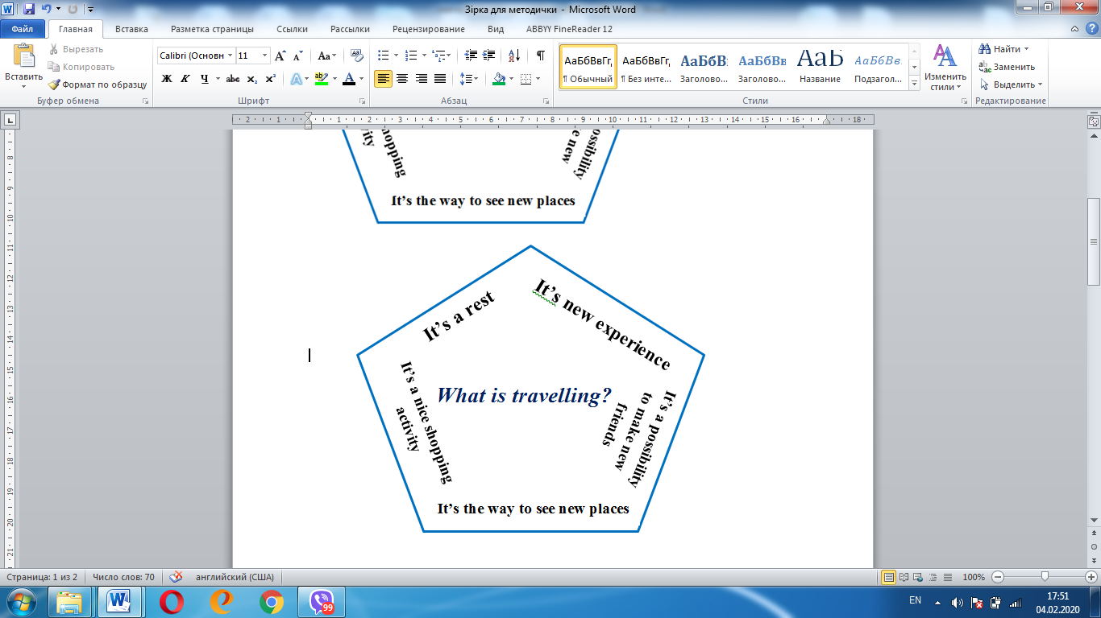
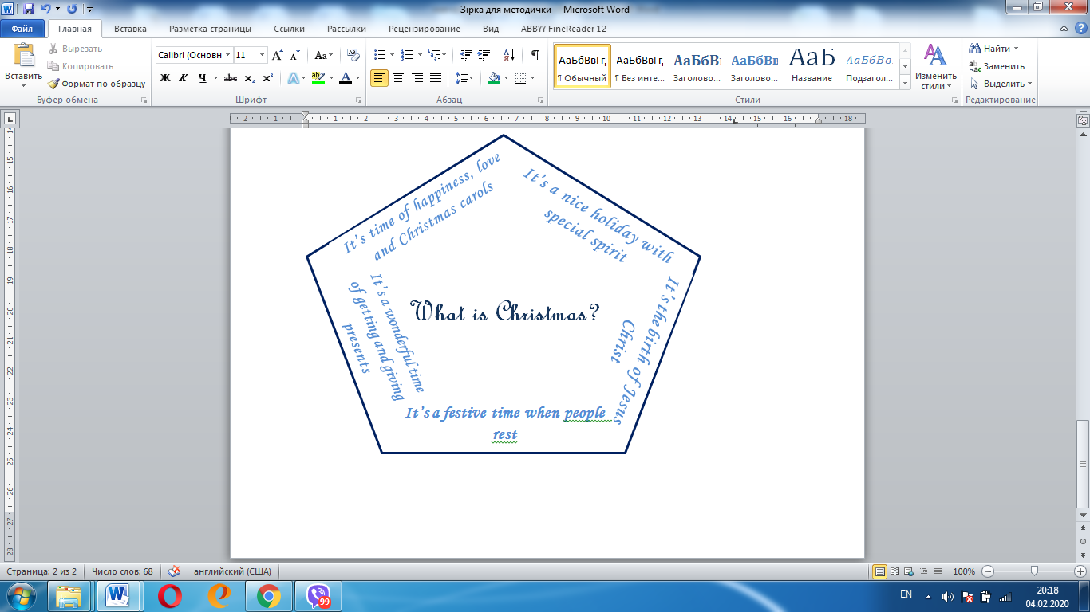

Writing a Letter
There are three main types of letters/email that course the writing style.
1. Informal: a letter giving news; a letter giving advice; an email making/accepting/refusing invitation; thanking, congratulating, apologizing, expressing regret/sympathy; a letter asking for/giving information, a letter describing people/places/events( a letter to someone you know well and have a good relationship with).
2. Semi-formal: any of the recalled previously letters (a letter/email to someone you know, but do not share cordial relationship with).
3. Formal: a letter applying for a post/course/job; an email asking/giving information; describing objects; a letter making a complaint/apologizing/; a recommending/making suggestion letter/email; an inviting/accepting/refusing an invitation letter; a letter to the editor ( it’s a business letter that displays professional contacts ).
Every letter has its structure and writing tools. As it has been told, students must write according to the instruction and they must be taught to understand it. They must understand the imaginary situation they will write about. Two years ago one of my curious students (a boy) asked me what to do if he would apply for a position of a dancer in a theatre. I answered:” Imagine that you are a ballerina “. It’s very important to imagine the situation and the reader of you letter. Suggest your students a scheme:

Helpful hints
Teacher should give clues to students till they are skilled writes. Helpful hints can be written or printed out (visual element). The task of the letter must be read in loud voice (auditory element) for better understanding. Students must underline key words. It is very important to write the piece of proper writing in the class: teacher can see abilities and difficulties of learners, how they can use helpful hints. They can discuss and do shared writing. For example, students have received an email from their English-speaking pen-friend.
I need some money to buy a present for my parents, but I don’t know what to do. Have you got any advice on what I can do to earn extra money?
Ann

While writing an informal letter giving advice (100 words) students can have the following hint which they prepare in the class while sharing ideas:
Structure | Defined | Visual | Clues | Examples of solution | The result of it
Problem  +pieces of advice giving  solution. | The text (letter) gives information about a problem and I explain one or more solutions. |  | Problem  solution | The best thing would be to find a weekend job.  Another good idea is to try gardening or babysitting.  Have you thought of selling some unwanted items online? | This will mean a stable income for you per week.  This will allow you to have some pocket money.  If you do this, you’ll get rid of your unwanted things and earn some money.
  Problem
  Solution |  | solution
There are letters that require description of a place. For example,
A friend of mine is thinking of visiting your country. Which place would you recommend for him to visit? What is special about it?
Thanks,
Mark

While writing an informal letter describing places (100 words for level B1) students can have the following hint which they prepare in the class while sharing ideas:
Structure | Defined | Visual | Clues | Plan of the description | Examples of description
Description  I write a reply to Mark and recommend place /places for his friend to visit. | I provide details or characteristics  of place/places |  | adjectives  characteristics  examples | Location of the place.  The sights.  What is there to see?  Activities to do | Vinnytsia is situated in the center of Ukraine.  Vinnytsia has a lot of places to visit. There are nice parks, squares, museums, monuments to famous people.  Visitors can spend a nice time watching the fountain “Roshen”.  There are plenty of fun activities to do. You can go cycling or boating along the river. There are many festivals that take place in summer.

If students have problems with opening and closing remarks, teacher can use the visual bank of phrases that must be prepared in advance. The helpful hints are not obligatory, but they are effective for training students to plan and write according to the plan, to use structures to support their ideas.

Writing in groups based on outline
When students have developed proper writing skills the teacher’s assistance can be less. Teacher can suggest writing in groups based on:
- the instruction of the letter;
- its outline;
- the bank of useful language according to the writing style.
This activity can be done after students have learnt about such kind of letters /emails or essays, they have read examples and teacher is sure in their abilities.

For example, task: you have seen this job advertisement and write a letter applying for the post.
Wanted – English language Teachers
English language teachers wanted to organize the interactive
process of studying and to teach successful writing at school.
Apply to Mr. Wright

Participants are given outlines (each group):

Students share and discuss ideas in groups, write on drafts using useful language tables:

They edit and present their letters. Then learners write an applying for a course letter individually.

Lesson planning. The example of the lesson
Тема:My World ( about me). Developing writing skills based on shared writing
Розробка уроку для учнів 5-го класу за підручником О.Карпюк
Формування предметних компетентностей: відпрацювати вживання вивчених лексичних одиниць і активізувати їх в писемному мовленні(лексичної); навчати усвідомлювати і контролювати організацію змісту висловлювання (семантичної); розвивати вміння будувати висловлювання у письмовій формі про себе, однокласників, друзів(комунікативної).
Формування ключових компетентностей: формувати інтерес до вивчення іноземної мови (саморозвитку та самоосвіти); уміння працювати з іншими на результат(соціальні і громадянські компетентності); вивчати іноземну мову з використанням спеціальних програмних засобів (інформаційно-цифрова компетентність).
Очікувані результати: на кінець заняття учні будуть вміти використовувати вивчені лексичні одиниці, структури для писемного продукування власного висловлювання, поєднуючи низку окремих коротких елементів у лінійну послідовність.
Обладнання та матеріали: картки для роботи в парах та групах, підручник «Англійська мова для 5-го класу» О.Карпюк, 2013; матеріали або скріншот сайту https://www.kidzworld.com/
Тип заняття: формування компетентностей.
The procedure
I.
1.Greeting.
T.Good morning, children! How are you getting on? I am very glad to see you here.
2. The aim and the tasks of the lesson:
Today we’ll continue speaking on theme. Help me to unscramble the word, please.
Olwrd. OK, it is WORLD . MY WORLD (about me).
You’ll practice in writing activities to gather ideas on how to write a letter about your world.
3. Phonetic exercise : read the transcription and write using letters (on the blackboard)
[wз:d] – word
[wз:ld] – world
4.Speaking & writing
What is it MY WORLD ?
Students brainstorm ideas and write them on the blackboard as a visual association

II. The main part of the lesson
1.Pair –work. Match the phrases you know:
Computer | your address
Good | Wizard
the best | at English
to find/found | in English
(to) have | a big family
Ukrainian | In a letter
(to)write to me | Friends
(to)write to me | town/city

Refer the phrases you have matched to the titles: write them down(with posters in two groups)
My family | (to) have a big family
My hobbies
My friends
My school and my classmates
My city
3. Read, guess and write down. Work in groups, write down in your exercise-books. Present your writing.
Ex.1 page 23. The exercise is based on the expressions above.
4.Group-work: questions and answers:
1)Unscramble the questions :
1. Have/ English/ got/ you/ friends/any?
2. have/ Do /want / friend /you/ to /email/ an?
2) Read the questions and answer them.
5. Writing process
1) prewriting : T. Children, look at the screen of our computer . What can you see?
Yes , it the site where you can find email friends. Read and write down the address.

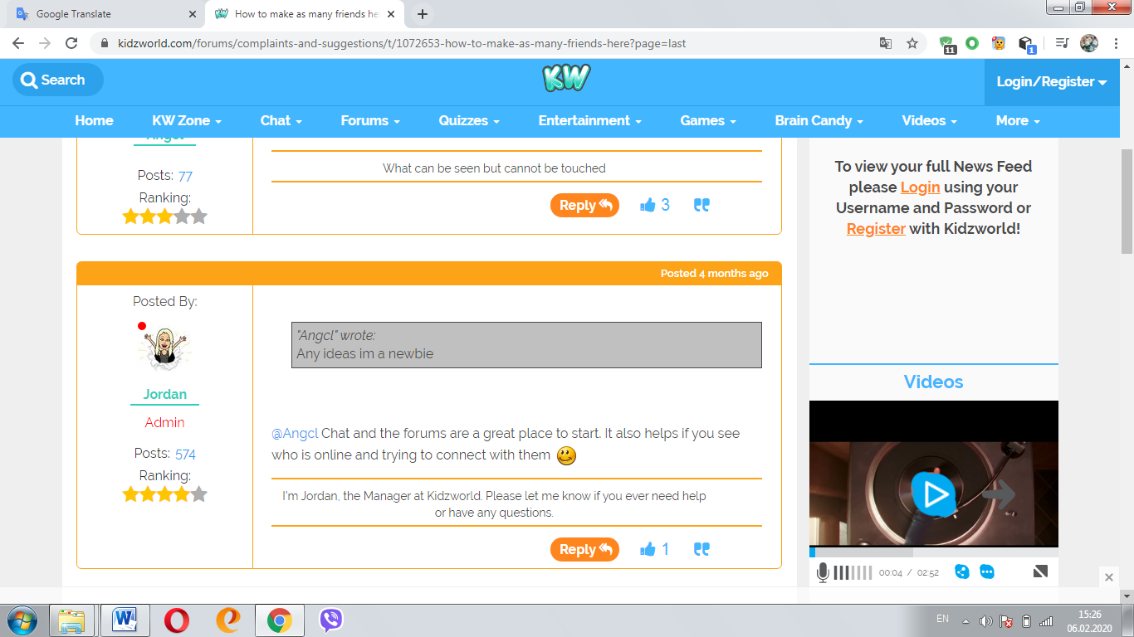
2)while writing- shared writing . A letter to a friend .
T. Ex.1 page 23. Look through the text and tell how to start writing a letter. Where is the closing remark /the end?

Structured | Defined | clues | examples
A letter to a friend | I write to an English boy and tell about my world | about me | My name is… I am (ten)
A letter to a friend | I write to an English boy and tell about my world | my family | I’ve got a big family; My family is not big.
A letter to a friend | I write to an English boy and tell about my world | my hobby | I am(not) a computer wizard. I am good at …but I am bad at…
A letter to a friend | I write to an English boy and tell about my world | my friends | I’ve got a lot of friends. Their names are..
 |  | my school and my classmates | My school is big and nice, I’ve got twenty-five classmates.
 |  | my city | My city is not very big but it’s clean. It is in Ukraine.
3)
4) individual work : write down a letter to an English pen-friend (or for homework)
III. The end
1. T.So now answer some of my questions :
- What do you write to find en email friend?
- Do you know how to write it?
- Do you like the lesson? If yes , draw the heart on the board.
2. Homework . Self-evaluation
Exercise 2 page 23. T. Open your books and read the task. Are you ready to do it? Complete your self-evaluation form.

Appendix
Appendix 1. Word formation
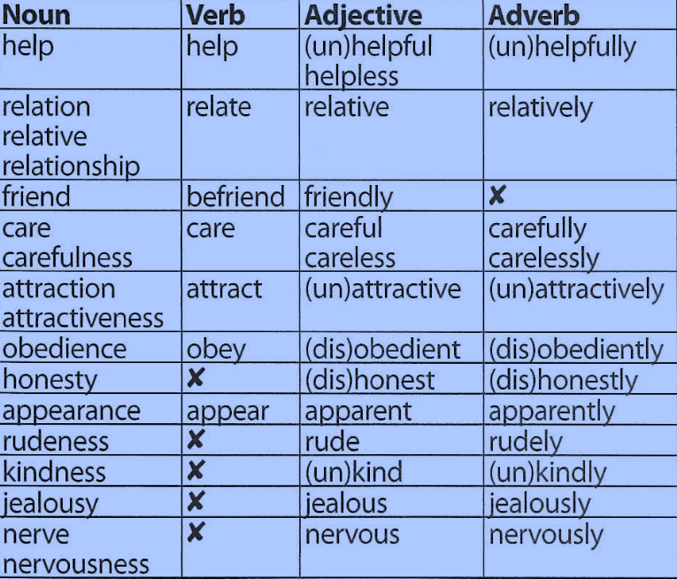
Appendix 2. Unscrambled words
Active, funny, shy, lazy, outgoing, polite, serious, rude, responsible, honest, popular.
Appendix 3. Letter cluster
ough is one of the trickiest spellings in English – it can be used to spell a number of different sounds.
Example 1. Ough +t = [ɔ:t] -ought
1.Ough-t to (modal verb). 2. B-ough-t, th-ough-t, br-ough-t, f-ough-t (past simple irregular forms).
Example 2.ough-[ᴧf ]
2. R-ough, t-ough (adjectives), en-ough (adverb after a verb, adjective or adverb ; determiner before uncountable and plural nouns).
Example 3. Ough-[әu]
3.Th-ough, al-th-ough (conjunctions); d-ough, d-ough-nut(nouns ).
Example 4. ough - [ә]
4.Tho-rough (adjective), bo-rough(noun).
Appendix 4. Synonyms
Use these verbs in their correct form to replace the words in bold
arrive ●become● buy ●find ●receive ●take

- I think we should buy a satellite dish so that we can receive more channels.
- I’d like to find/take a job in the media and learn more about current affairs.
- When the journalist arrived home, she turned on the TV to watch the news.
- Georgia didn’t want to be late for the interview so she took a taxi.
- Mike became annoyed when he was given a low mark for his essay on the media
Appendix 5. Word patterns
Adjectives | bored with  crazy about  good at  interested in  keen on  popular with | verbs | feel like  listen to  take part in
Adjectives |  | nouns | a book (by sb) about  a fan of  a game against
Appendix 6.Replacement exercises for the 5th formers
Read the model paragraph below and then look at the information about Alfredo and Teresa. Rewrite the model paragraph and use the information about Alfredo to write a description of him. Write another paragraph and use the information about Teresa to describe her.
Alfredo is a boy from Venezuela. He lives in Caracas. He is thirteen years old. He studies English in school. His hair is brown. His eyes are brown. His favourite sport is running . His hobbies are riding a bicycle, watching TV . Alfredo has one brother. His name is Roberto. He has one sister, too. Her name is Teresa. Roberto has a pet dog. Its name is Charlie.

Appendix 7. Gapped text

Dear Susan,

1) Thank you for your letter. 2) Sorry I have taken so long to put pen to paper.3) Anyway I thought I’d drop you a line to let you know how I’m getting on.

4) I am happy to hear that you are preparing to take part in the School Talent Competition.5)I think you’ve made the right decision! 6) Moreover, I’m sure that you shouldn’t be shy since your special talent is great!

7) I’m convinced that sharing you talent with others is very important as it makes other people happy and boosts your confidence.8) Besides, the more you practice, the more brilliant your talent becomes, which, in its turn, makes you a more interesting personality.

9) I am good at Oriental dancing. I go to dance class three times a week and I take every opportunity to practice it outside the class.10) Therefore, I regularly take part in various competitions and shows.

11) Sorry, my mum is calling me, so I must finish now.12) Hope to hear from you soon.

Best wishes,

Kate

Appendix 8. Reordered text
- Dear Susan,

- I am happy to hear that you are preparing to take part in the School Talent Competition. I think you’ve made the right decision! Moreover, I’m sure that you shouldn’t be shy since your special talent is great!

- Thank you for your letter. Sorry, I have taken so long to put pen to paper. Anyway, I thought I’d drop you a line to let you know how I’m getting on.

- Sorry, my mum is calling me, so I must finish now. Hope to hear from you soon.

- I am good at Oriental dancing. I go to dance class three times a week and I take every opportunity to practice it outside the class. Therefore, I regularly take part in various competitions and shows.

- I’m convinced that sharing you talent with others is very important as it makes other people happy and boosts your confidence. Besides, the more you practice, the more brilliant your talent becomes, which, in its turn, makes you a more interesting personality.

- Best wishes,

- Kate

Appendix 9. Controlled Composition .Incomplete letter for the 5th formers
Use the form below. You may add more sentences if you wish. Be sure to give your correct address at the top. Use correct punctuation and capital letters.
22 Andriya Pervozvannogo street
Vinnytsia,21027
Ukraine
May 22 , 2019
Dear Nina,

I am very happy to write you. My name is Ann. I live in Vinnytsia.
I am 11 years old. I am a pupil. I have blue eyes and long fair hair. My hobbies are dancing and reading. My father is a lawyer, and my mother works at a hotel. I have two brothers. Their names are Nick and Andrew.
My city is beautiful. The weather is warm. The winters are not very cold, but I like it. Do you have any brothers or sisters? Do you have any hobbies? Are you interested in reading? Are you a good writer? Please write and tell me about yourself.
Yours,
Ann.

Appendix 10. Visual mnemonic
While understanding is always better than memorizing, there are times when you’ll need a few tricks to help the brain remember.
Op.SASh.com | Opinion
Op.SASh.com | Size
Op.SASh.com | Age
Op.SASh.com | Shape
Op.SASh.com | Colour
Op.SASh.com | Origin
Op.SASh.com | Material
Task. Put the adjectives in the correct order.
Peter is a nice little boy. He has got short straight fair hair and big blue eyes.

Appendix 11
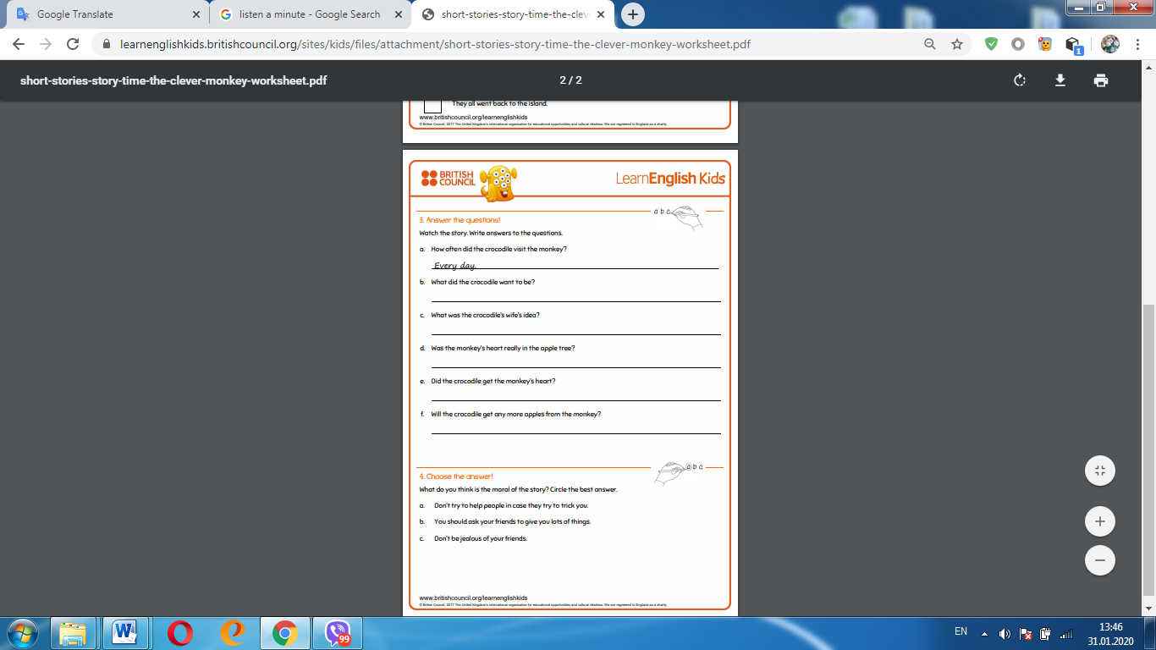

Appendix 12.
1)Life of Pi is a fantasy film based on the novel written by Yann Martel
2)The film is directed by Ang Lee
3)It is set in the Pacific Ocean .
4)The main actor is Suraj Sharma who plays the leading role of Pi Patel
5)The film is about survival on the high sea.
6)Pi Patel and his family travel from India to Canada on the board of the ship with animals from their zoo.
7)The ship sinks in a terrible storm.
8)Pi survives in finds himself on a boat with some of the animals a including fierce Bengal tiger.
9)Pi stays alive in the open ocean on a life boat with these strange travelling companions
10)The most advanced 3D images are brought to the screen in this fantasy film.
11)The deep ocean, the animals and sometimes even Pi are created by computers, but they look realistic.
12)The remarkable story and the brilliant special effects make tis film a must-see.

Sourses
- Англійська мова:Підручник для 5-го класу загальноосвітніх навчальних закладів . -Тернопіль: «Видавництво Астон», 2019.
- Новий Закон України «Про освіту» https://mon.gov.ua/storage/app/media/zagalna%20serednya/BOOKLETTE_INFO-ZAKON-2018_PRESS.pdf.
- Навчальні програми з іноземних мов для загальноосвітніх навчальних закладів і спеціалізованих шкіл з поглибленим вивченням іноземних мов. 5-9 класи, Київ, 2017 р.
- Developing Writing Skills/Writing Skills Practice Book for Beginning/Intermediate Students of English as a Foreign Language by Patricia Wilcox Peterson.-English Language Programs Division/United States Information Agency Washington ,D.C.20547.
- On Screen/Writing Book by Virginia Evans-Jenny Dooley.-Express Publishing,2014.
- https://learnenglishkids.britishcouncil.org/short-stories/the-lion-and-the-mouse.
- https://www.thoughtco.com/quick-writing-prompts-p2-2081846
- LONGMAN Exams Dictionary, p.1220
- https://busyteacher.org/11013-getting-kids-ready-to-write-4-easy-strategies.html
- https://www.kidzworld.com/

THE NEW UKRAINIAN SCHOOLCONCEPTUAL. PRINCIPLES OF SECONDRY SCHOOL REFORM,p.11
https://learnenglishkids.britishcouncil.org/short-stories/the-lion-and-the-mouse
LONGMAN Exams Dictionary, p.1220
https://busyteacher.org/11013-getting-kids-ready-to-write-4-easy-strategies.html

